Topic: Measurement | EQ: How do we compare and order different units?
Questions  Comparing units  Using estimation  Example | Notes:  To compare units, we need to understand which units represent larger amounts.  For example; 10cm is a lot smaller than 10m and even more smaller than 10km  We can use comparisons of objects to estimate the size of different attributes.  For example, if we know an elephant weighs 5000 kilograms, we might estimate a rhinoceros weighs 2500 kilograms as it is approximately half the size.  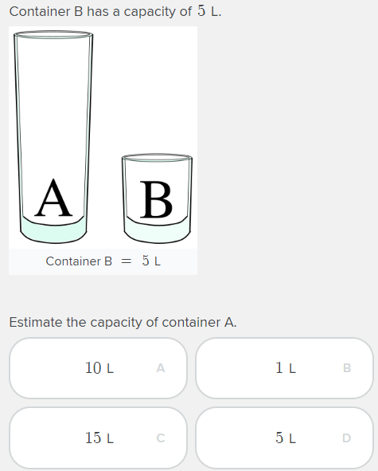  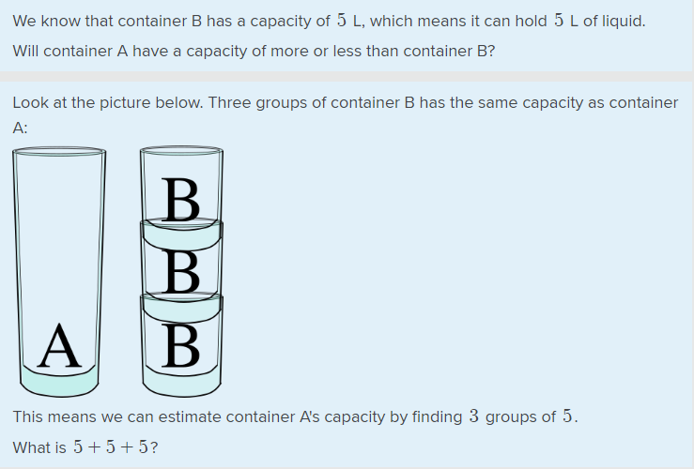
Activity
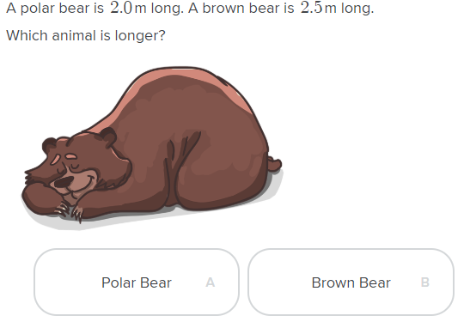 | 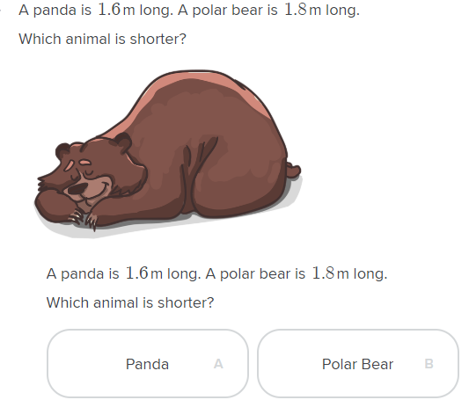
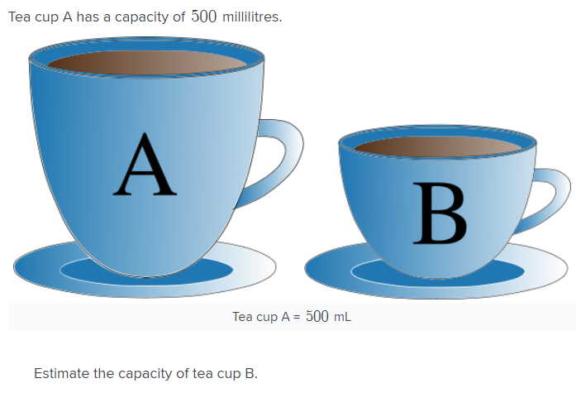 | 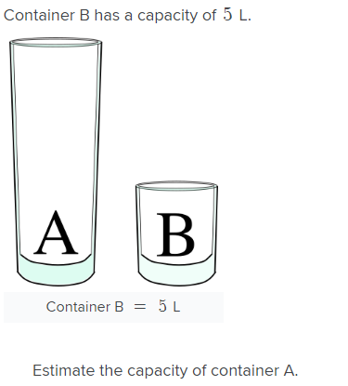
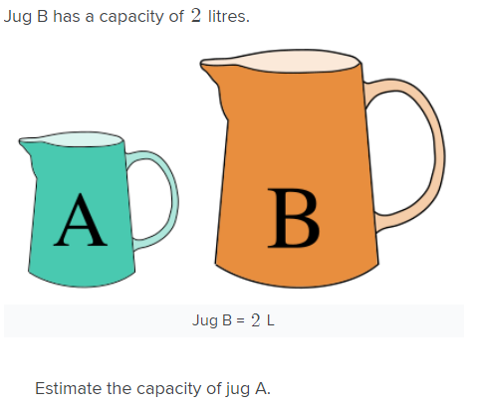 | 